**Assignment Details:**

**Task:** Given 600 images of the electronic component (as in attachment), train a machine learning algorithm that could detect the acceptable or non-acceptable (‘faulty’) orientation of the electronic component as described below. Note that the only difference between acceptable and non-acceptable is the orientation of the component in the grid:

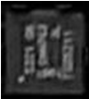 acceptable

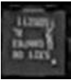 not acceptable

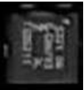not acceptable

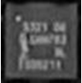not acceptable

**Hint:** The dataset contains only acceptable orientation images while an example of faulty orientation images is in the “faulty” folder. You should find a way to train the classifier for detecting faulty orientation using the ‘acceptable orientation’ large dataset given, such as creating more good/faulty data with data augmentation or manipulation on the given dataset.

**Tools and Open Source:**We recommend you use either [CAFFE](http://caffe.berkeleyvision.org/)or [TensorFlow](https://www.tensorflow.org/) or [Keras](https://keras.io/) or [Pytorch](https://keras.io/" \t "_blank), however you can still use other tools.  You are also free to use any resources to accomplish the assignment, including: code samples, open source libraries, research materials etc.

**Deliverables:**

* A **program with code**, **executable** (with all required dependencies library if not in Python) and **the trained model** for our evaluation purposes (preferable in C++ and windows-based, we will however still accept python in any operating system).
* The program should be able to load an image or a folder (and then process all images in the folder) for testing and training purposes.
* The program must also be able to output the detection report into a text/html/excel file (your choice).
* Prepare a presentation slides/report that describes your approach of machine learning algorithms, the assumption made and the limitation if any.